YOUTH WRESTLING TOURNAMENT

Sunday December 18th, 2022

Wrestling to start at 9:00am
Menasha High School Fieldhouse
Enter through Door #15
420 7th St Menasha
(Main Parking Lot on 8th St.)

FOLKSTYLE TOURNAMENT
Grades PreK-8th
Boys Divisions: Pre-K - K, 1st - 2nd, 3rd - 4th, 5th - 6th, 7th - 8th
Girls Divisions: K-2nd, 3rd - 4th, 5th -6th, 7th - 8th (subject to change based on numbers)
4 person round robin bracketing
3--1 minute periods for Prek-5
3 -- 90 second periods for 6th - 8th
NO USA CARD REQUIRED
WIAA refs on most mats

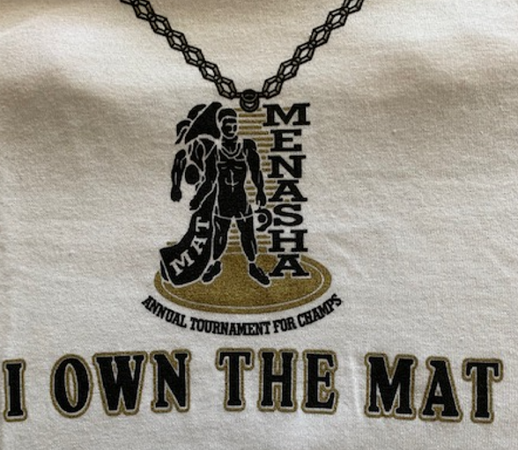

Register on Trackwrestling.com

Registration will close 5:00pm on December 17th or when full
500 wrestler limit
Entry Fee $20.00
Walk-ins not allowed

Awards:
Trophy, and a T-shirt for 1st place, Custom medals for 2nd-4th
Custom pins awarded for each individual pin
TEAM TROPHY 1st-3rd place
$20 entry for each 10 wrestler team

Weigh-ins will be Saturday Dec 17th 5:00pm to 6:30pm and Sunday Dec 18th from 7am to 8am Must be within 2 lbs of the registered weight. Brackets may be adjusted based on weight from weigh in.
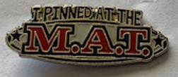
Admissions:
$3.00 per adult
$2.00 seniors 55 or older
Children 6 and under free
Concessions available all day

Contact: Jamie Petersen Johnson (920) 540-5273

